**QUINONEZ, AILEEN PEARL**

**WEB DEVELOPMENT CPRG 306_D**

GIT

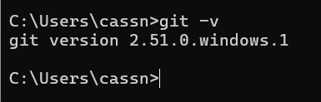

GITHUB ACCOUNT

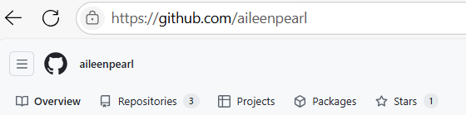

GITHUB DESKTOP



GITHUB STUDENT DEVELOPER PACK

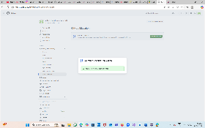

NODE.JS

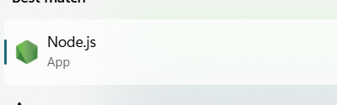

VISUAL STUDIO CODE



VISUAL STUDIO CODE EXTENSIONS:

GITHUB COPILOT

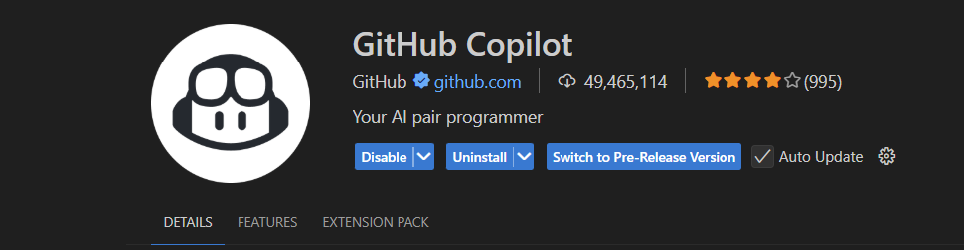

PRETTIER – CODE FORMATTER

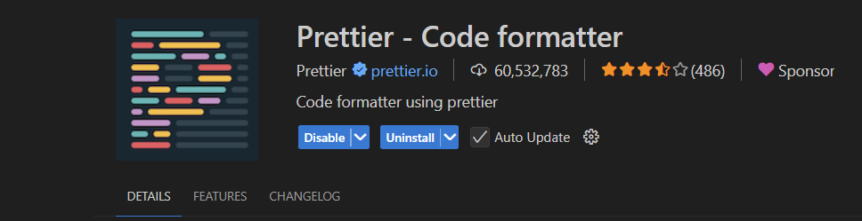

TAILWIND CSS INTELLISENSE



CODE SPELL CHECKER